Howard Banta

Chapter Meeting

2005 GLAR
[ This is our Chapter report, sent to the National, from our meeting that occurred during the 2005 Greater Los Angeles Regional (GLAR) convention. Contributed by Phyllis Angell]
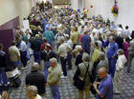
The lobby at opening
medium or full size image
The most recent meeting of the Howard Banta Alarm Clock Chapter #178 (HBACC) met on Friday, February 4, 2005, at the Greater Los Angeles Regional in Pasadena, California.
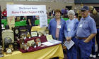
Remembering Howard Banta
medium or full size image
In lieu of a regular meeting, a large alarm clock display and slide program was open to all interested convention attendees. There were over 60 alarm clocks of various sizes and shapes on display to pique the interest of old and new collectors alike.
As a special treat, the H. J. Davies patented Illuminated Alarm Clock was displayed along with three unusual Darche alarm clocks. Please look for the color article on the Illuminated Alarm Clock in the April issue of the Bulletin.
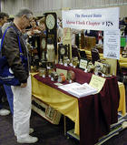
Marshall Knolton at the HBACC display
medium or full size image
In addition to the comprehensive alarm clock display, the classic NAWCC Program "Alarm Clocks are Collectible" was shown. This 22-minute slide program continues to intrigue both the beginning and advanced collector. This slide program is available from the NAWCC lending library.
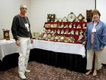
Marshall and Phyllis
medium or full size image
Two HBACC members graciously brought recently acquired alarm clocks for show and tell. Mr. Marshall Knowlton proudly displayed his Herschedes alarm clock from the 1950's with the original box and instructions.
Mr. Robert Linkenhofer happily showed the group his restored double-bell alarm clock believed to be German with a Turkish numeral dial.
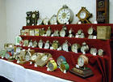
Alarm clock display
medium or full size image
Chapter President, Vince Angell, then conducted a short meeting. He began by introducing Mary Maier, Newsletter Editor, who received well-deserved applause from the audience for her outstanding work on the quarterly newsletters.
Vince then brought up the possibility of re-doing and updating the club by-laws. He mentioned the chapter goal in 2005 was to create two new alarm clock programs, and last, he discussed the possibility of developing an official HBACC Internet forum.
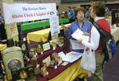
Prospective member
medium or full size image
Besides the scheduled HBACC meeting/program, Vince displayed a smaller number of charming alarm clocks at his Mart table. This smaller display of alarm clocks, along with a large banner announcing the HBACC, a stack of the recent newsletter, and membership applications, received a great amount of attention from the convention attendees and netted at least two new members to the HBACC.
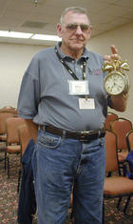
Bob Linkenhofer showing his new acquisition
medium or full size image
Plans are already in the works for the 2006 Greater Los Angeles Regional in Pasadena. The HBACC hopes to have a new slide program of the Howard Banta alarm clock collection.
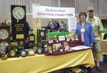
Vince and Phyllis
medium or full size image
A larger display in the Mart room is being taken under consideration for attracting new members and for the enjoyment of even the members of the National that do not collect alarm clocks but who love clocks and watches.

