Howard Banta

Chapter Meeting

2004 GLAR
[ This is our Chapter report, sent to the National, from our meeting that occurred during the 2004 Greater Los Angeles Regional (GLAR) convention. Contributed by Vince Angell]
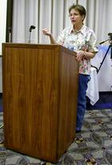
Mary at Podium
medium or full size image
The 2004 Greater Los Angeles Regional in Pasadena, California was host to the most recent NAWCC Alarm Clock Chapter #178 meeting. Recently, the President and guiding force of the Alarm Clock Chapter, Howard Banta, passed away. Howard Banta was one of the founding members and a past President of the San Fernando Chapter 75. He was a NAWCC Fellow and served a term as a National Director.
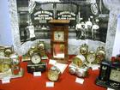
Darche Display
medium or full size image
The quarterly Newsletter has been renamed the Howard Banta Alarm Clock Chapter Newsletter and a more formal change in the name of the Alarm Clock Chapter #178 to this designation is underway. He will be sorely missed. It was a small meeting with about 12 members and also joining us for discussion was one of our members and National Director, Mary Ann Wahlner.
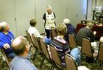
Mary Ann
medium or full size image
We were very please to have as a slide Program, "Alarm Clocks Are Collectible". This was presented by member Vincent Angell. This program was developed for the Sacramento Valley Chapter and the NAWCC in 1978 by Vince, Ronald Hoops and John Fossette. Even though the program was 25 years old, it still was an extremely informative program for both the advanced and beginning collectors of Alarm Clocks.
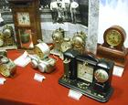
Darche Display
medium or full size image
The membership was also treated to a fabulous display by Vince on the Darche Electric Alarm Clock. This was basically a novelty clock made in the Chicago vicinity at the turn of the century. Started in 1892 by George Darche and his brothers this fascinating story on actually building out of the rubble of the Chicago fire and finally ending with the start of the Depression in 1929.
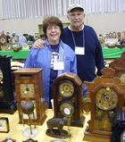
Phyllis and Vince
medium or full size image
Vince also shared with the members and guests a small booklet he developed on the Company with the help of the Great, great granddaughter of both George and Eugene Darche. This information definitely added that Personal Touch to the Book. A great article on the Darche Company was written by Judith Z. Rubin entitled "The Darches and Me" can be found in the June 1993 publication of the NAWCC Bulletin.
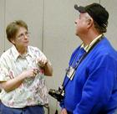
Mary and Mike
medium or full size image
Another discussion was that the next Newsletter was being written and would be in the mail and on the internet by the middle of March. Our Editor, Mary Maier, has been quite the developer of the Newsletter and all her hard work has been very much appreciated.

