Howard Banta

Chapter Meeting

2007 GLAR
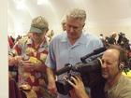
Huell Houser
medium or full size image
[ This is our Chapter report, sent to the National, from our meeting that occurred during the 2007 Greater Los Angeles Regional (GLAR) convention. Contributed by Phyllis Angell ]
Many members of the Howard Banta Alarm Clock Chapter #178 (HBACC) met in Pasadena, CA on February 1st and 2nd, 2007 at the Greater Los Angeles Regional (GLAR).
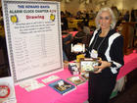
Grand Prize Winner
medium or full size image
In lieu of a specific program, HBACC President, Vince Angell, provided a marvelous and extensive display of alarm clocks at his table in the Mart Room. Also, in behalf of the HBACC membership, he conducted a free drawing for fun alarm clock related prizes.
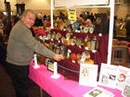
NAWCC Treasurer Peter Klein admires display
medium or full size image
There were eleven prizes ranging from four, one-year free memberships to the HBACC, four colorful books on alarm clocks, two new alarm clocks from Brookstone, and the Grand Prize, the "CLOCKY", which has been featured in recent HBACC newsletters. The display and raffle were received with great interest and lots of kudos.
For the first time in the history of the NAWCC the organization tried something different at this Regional by inviting the public to attend the Mart on the last day. Over four hundred non-NAWCC members attended. Many Mart sellers were pleased that the public purchased their clocks and watches.
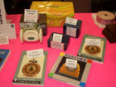
Prizes
medium or full size image
Since the public was invited to attend this Regional, the media was also invited. Mr. Huell Howser from the PBS show California Gold interviewed and filmed many mart table holders. The HBACC Alarm Clock display received honored attention from Mr. Howser.
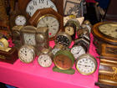
Sale Alarms
medium or full size image
Vince and Phyllis Angell told Mr. Howser about the Chapter and many of the display clocks were filmed. Please watch this site in the near future for the video of Phyllis Angell's interview with Huell and a great display of alarm clocks
As stated above, four new members were signed up at this regional. We feel that having a display in the Mart Room and being readily available to talk with the attendees is a much better and successful way to attract new members rather than having a separate off-site meeting where only a few HBACC members and practically no non-members attend.
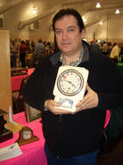
New Purchase
medium or full size image
The drawing also appears to be successful in growing our chapter. Out of the four free memberships available, one new member signed up at the regional, two winners took their free memberships home (hope they complete and return them), and one prize was not claimed. If we receive the two additional applications, we will have obtained six new members. Not bad!
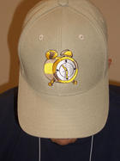
Alarm Hat
medium or full size image
It is because of the contributions and support for the Chapter from numerous Members and Guests of Chapter 178 that the Newsletter has been recognized as one of the best if not the best Newsletter of any local chapter in the NAWCC. Thank you to all that contribute and share their knowledge.
If you have this love and interest in Alarm Clocks and want to join this Chapter please fill out the member form and send to Mike Wilson. You must be a current member in good standing of the NAWCC.
This membership entitles you to all newsletters during the year from January 1 through December 31. You also receive the official Howard Banta Alarm Clock Chapter lapel pin to be worn proudly at meetings and Regionals.

